**Occupation Competition Model between Artificial Intelligence and Human**

Ming Cheng

Department of Applied Math, University of Washington

Amath 383: Introduction to Continuous Mathematical Modeling

Dr. Mark Kot

March 9, 2023

**Occupation Competition Model between Artificial Intelligence and Human**

**Abstract**

The rapid development of artificial intelligence is a hot topic among people, but many surveys have shown that the efficiency of AI causes employees in many positions to face the risk of being replaced. To further study the job competition relationship between humans and AI in the future, I have established two models to each focus on the impact of the interaction between humans and AI on their job competition and predict who will win the job competition eventually. According to the stability analysis and integration, the Lotka–Volterra competition model shows that AI is likely to replace humans as the effect of AI on humans increases, while another model shows that both humans and AI have the chance to replace each other.

**Introduction**

Over the past few years, humanity has advanced technologically to an unprecedented degree. With the popularization of general-propose technology, a new technological revolution will happen. In November 2022, Chatgpt, an intelligent chat robot developed by OpenAI, became the focus of everyone's attention. This artificial intelligence based on the GPT-3 large-scale language model can allow people to improve work efficiency in many fields (Aljanabi, 2023) and even beat skilled employees in some fields.

Technological changes have also occurred many times in history. Since applying new technologies may lead to job replacement and loss, many resistances exist to popularizing new technologies. In 1589, William Lee invented the stocking frame knitting machine and went to London to seek patent protection, but the Queen rejected it because it might deprive some people of employment opportunities (Acemoglu & Robinson, 2012). The "Luddite" riots between 1811 and 1816 also demonstrate artificial fear of technological change (Mantoux, 2015).

The transformation of AI is even more unprecedented than any technological transformation in history. Although, The Industrial Revolution created more new jobs while reducing jobs. Like Bruun says, "But AI challenges this model, as jobs across the whole employment spectrum are simultaneously challenged by a technology that combines the speed and efficiency of a machine with the creativity and agency of a human" (Bruun & Duka, 2018). On the other hand, Chat GTP has been able to replace part of the work of junior doctors to a certain extent and improve the quality of the discharge summary itself (Patel & Lam, 2023). AI also has made outstanding achievements in agriculture. Using mathematical models, AI has designed a very accurate and efficient drip irrigation system for sustainable agriculture and the environment (Klyushin & Tymoshenko, 2021). In addition to the outstanding achievements of AI in these tasks that require many knowledge reserves, it has even replaced workers in specific jobs. According to Wakefield, China is investing heavily in robotic workforces. Apple and Samsung supplier Foxconn has replaced 60,000 factory workers with robots (Wakefield, 2016). As more data becomes available, AI will become more competitive with the automatic improvement of capabilities. It calculates that 47 percent of all jobs in the U.S. economy fall into the high-risk category, jobs that could be easily automated within the next two decades (Frey & Osbourne, 2017).

On the contrary, some articles show that there are still many potential problems with AI. Castelvecchi pointed out in his article that neither chat GTP nor Alpha Code can only perform limited tasks, and there is still a long way to go to replace human software engineers (Castelvecchi, 2022). In addition, OpenAI itself has admitted that there may be misleading or biased content in ChatGTP's output, such as citing non-existent article references or perpetuating sexist stereotypes. It can also respond to harmful commands, such as generating malware (The Lancet Digital Health, 2023).

Given the differences in the above research on the impact of AI on humans from this introduction, I will build two mathematical models in the Mathematical Model section and demonstrate the intervention and competition between AI and humans using graphing and stability analysis in the analysis section. Lastly, I will summarize my result and describe the limitations of the models in the conclusion section.

**Mathematical Model**

**The relationship between humans and AI may include various forms of competition. To analyze the competitive relationship between AI and human beings in future jobs more comprehensively, I will use two different models to explain the competitive relationship between them.**

***Interference Competition***

**My model in this approach is to apply the standard Lotka–Volterra interference competition model. We first assume that there are H human positions and A artificial intelligence positions, and the number of these positions increases logistically without heterogeneous interference. With the continuous advancement of technology, AI will also advance rapidly, which means that the c**ompetitiveness**of AI will continue to grow and the impact of AI on humans in the competition will also increase. To parameterize this effect, we will use $α_{HA}$ and $α_{AH}$ to explain the strength of the effect of AI on humans and of humans on AI,**

$\frac{dH}{dt}= \frac{r_{H}}{K_{H}}H\left(K_{H}-H- α_{HA}A\right),$**(1)**

$\frac{dA}{dt}= \frac{r_{A}}{K_{A}}A\left(K_{A}-A- α_{AH}H\right).$**(2)**

**I use the Lotka–Volterra competition model reflecting how humans and artificial intelligence interact with each other without introducing time, "t". In the next section, I will analyze how the equilibria change in response to any changes in $α_{HA}$.**

***Limited Jobs Competition Model***

**The Multistrain disease model inspires this model. Let's assume there are A AI and H humans in the job market with U unemployed, E employee, I idle AI and W working AI. And we also suppose the available or unoccupied, J, increase logistically according to the equation**

$\frac{dJ}{dt}= μ \left(K-J\right)= μK- μJ.$**(3)**

**This equation shows linear growth at low job demand but exponentially approaches the carrying capacity K at high job demand. This means the number of unoccupied jobs is increasing at a rate of $μ$ (K－J), that is, proportional to the differences between job capacity and current unoccupied jobs.**

**Since the unemployed AI and humans are looking for jobs, they start to explore and connect with these unoccupied jobs. In this case, the unoccupied jobs decrease at the rate of $β_{1}JU+ β_{2}JI$, where $β_{1} and β_{2}$ are the proportional coefficients. Unoccupied jobs fell to the reason that unemployed humans and idle AI got jobs and became employees and working AI. As the number of unemployed humans and idle AI goes down, and the number of employees and working AI goes up at the same rate, $β_{1}JU and β_{2}JI.$**

**According to the assumption above, we can produce the following model,**

$\frac{dJ}{dt}= μK- β_{1}JU- β_{2}JI- μJ$**, (4)**

$\frac{dE}{dt}= β_{1}JU,$**(5)**

$\frac{dU}{dt}= - β_{1}JU,$**(6)**

$\frac{dW}{dt}= β_{2}JI,$**(7)**

$\frac{dI}{dt}= - β_{2}JI.$**(8)**

**Analysis**

**In this section, we will use the Jacobian matrix to analyze the stability of the corresponding equilibrium points of each model and predict the competitive relationship between AI and humans in future jobs.**

***Interference Competition Model Analysis***

**As we know, the interference competition model has three or four equilibriums depending on the interference coefficient. Since we only focus on positive numbers of humans and AI, we will ignore the equilibrium point at the origin and pay more attention to the boundary and interior equilibrium.**

**To calculate the equilibrium points, we set equations (1) and (2) equal to zero, solve for A* and H* respectively, and then combine the corresponding values of A* and H* obtained by the two equations. The four equilibriums we get are (0, 0), (0, KA), (KH, 0) and ($\frac{K_{H}-α_{HA}K_{A}}{1-α_{AH}α_{HA}}, \frac{K_{A}-α_{AH}K_{H}}{1-α_{AH}α_{HA}})$.**

**Next, we will calculate the Jacobian matrix. In order to simplify the calculation, we will call $"\frac{r_{H}}{K_{H}}\left(K_{H}-H- α_{HA}A\right)"$ from equation (1) f and $"\frac{r_{A}}{K_{A}}\left(K_{A}-A- α_{AH}H\right)"$ from equation(2) g. In this way, the Jacobian matrix we get is**

$J= \left(\begin{matrix}f+H\frac{∂f}{∂H} & H\frac{∂f}{∂A} \\ A\frac{∂f}{∂H} & g+H\frac{∂g}{∂A}\end{matrix}\right)$**, (9)**

**so that we can check the behavior at each positive equilibrium.**

**At (0, KA),**

**(10)**

**Since this is a diagonal matrix, we directly conclude that the eigenvalues are**

${ λ}_{1}= \frac{r_{H}}{K_{H}}\left(K_{H}- α_{HA}K_{A}\right), { λ}_{2}= -r_{A}$**. (11)**

**We notice ${ λ}_{2}= -r_{A}$ is always negative. However, the sign of the other eigenvalue depends entirely on $\left(K_{H}- α_{HA}K_{A}\right).$ We start to look at when AI has less of an impact on humans, that is, $α_{HA}< \frac{K_{H}}{K_{A}}$. Because $K_{H}> α_{HA}K_{A}$ in this case, then one of our eigenvalues is positive and the other is negative, which means that (0, KA) is a saddle point. This reflects that when AI was first introduced to work, the interference coefficient to humans was small, and it could not replace humans in completing various tasks. Nevertheless, with the innovation of technology, $α_{HA}$ is increasing. When ${ α}_{HA}> \frac{K_{H}}{K_{A}}$, both eigenvalues become negative, meaning the original saddle equilibrium becomes a stable node. This implies that AI will win this competition. Because when the number of working AI is greater than the number of employed humans initially, and the number of employed human and AI will approach toward the stable equilibrium at (0, KA), where the number of employed human is equal to 0, as shown in figure 1.**

**Another place we need to pay attention to is ${ α}_{HA}= \frac{K_{H}}{K_{A}}$, this is a bifurcation point because it separates the stable and saddle parts of (0, KA), producing a transcritical bifurcation. Similarly, a transcritical bifurcation with bifurcation point at ${ α}_{AH}= \frac{K_{A}}{K_{H}}$. As shown in Figure 2, when the human intervention coefficient on AI increases, ${ α}_{AH}> \frac{K_{A}}{K_{H}}$. At this time, the increased influence of humans will lead to the change of stability from unstable to stable.**

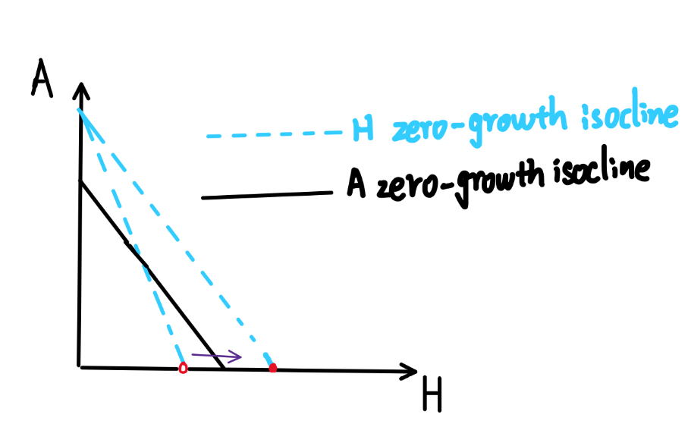

**Figure 1 Figure 2**

**Additionally, we will focus on the internal equilibrium. For the convenience of referring to this more complicated equilibrium, we will call ( $\frac{K_{H}-α_{HA}K_{A}}{1-α_{AH}α_{HA}}, \frac{K_{A}-α_{AH}K_{H}}{1-α_{AH}α_{HA}})$ as (x, y), with x and y being both positive numbers. Notice that since x and y are both positive, then the sign of $K_{H}-α_{HA}K_{A}$ and $K_{A}-α_{AH}K_{H}$ must be the same, and this internal equilibrium only occurs when ${ α}_{AH}> \frac{K_{A}}{K_{H}}, { α}_{HA}> \frac{K_{H}}{K_{A}}$, or ${ α}_{AH}< \frac{K_{A}}{K_{H}}, { α}_{HA}< \frac{K_{H}}{K_{A}}$.**

**Let's look at the Jacobian matrix at (x, y),**

$J= \left(\begin{matrix}-\frac{r_{H}}{K_{H}}x & -\frac{r_{H}}{K_{H}}α_{AH}x \\ {-\frac{r_{A}}{K_{A}}α}_{HA}y & -\frac{r_{A}}{K_{A}}y\end{matrix}\right)$**. (12)**

**This matrix has the characteristic equation**

${ λ}^{2}+(\frac{r_{H}}{K_{H}}x+$ $\frac{r_{A}}{K_{A}}y)λ+ \frac{r_{A}}{K_{A}}\frac{r_{H}}{K_{H}}\left(1-α_{AH}α_{HA}\right)xy=0,$**(13)**

**where q = $\frac{r_{A}}{K_{A}}\frac{r_{H}}{K_{H}}\left(1-α_{AH}α_{HA}\right)xy$, p = $(\frac{r_{H}}{K_{H}}x+$ $\frac{r_{A}}{K_{A}}y).$ From here, we can clearly see that p is always negative and the sign of q depends on 1 $-α_{AH}α_{HA}.$ When it is less than 0, we have ${ q is less than 0 and α}_{AH}> \frac{K_{A}}{K_{H}}, { α}_{HA}> \frac{K_{H}}{K_{A}}$, then the interior equilibrium is a saddle-node in this case. This reflects both humans and AI have great interference with each other, and the advantage of either side's initial condition can wipe out the other side from the competition. And the change of the interference coefficient on either side will cause (x, y) to approach the boundary equilibrium, and when the interference coefficient of any side begins to less than $\frac{K_{H}}{K_{A}} or \frac{K_{A}}{K_{H}},$ (x, y) coincides with the boundary equilibrium, resulting only three equilibriums .**

**On the contrary, if 1 $-α_{AH}α_{HA}>0$, we have ${ α}_{AH}< \frac{K_{A}}{K_{H}}, { α}_{HA}< \frac{K_{H}}{K_{A}},$ and q is greater than 0. In order to distinguish whether this is a node or a focus, we need to justify whether $\frac{p^{2}}{4}-q$ it is greater than 0. Using basic arithmetic, we get**

$\frac{(\frac{r_{H}}{K_{H}}x+ \frac{r_{A}}{K_{A}}y)^{2}}{4}-\frac{r_{A}}{K_{A}}\frac{r_{H}}{K_{H}}\left(1-α_{AH}α_{HA}\right)xy= \frac{(\frac{r_{H}}{K_{H}}x- \frac{r_{A}}{K_{A}}y)^{2}+ \frac{r_{A}}{K_{A}}\frac{r_{H}}{K_{H}}α_{AH}α_{HA}xy}{4}> 0 .$**(14)**

**This means that (x, y) is indeed a stable node. In this case, humans and AI have less interference with each other, and the distribution of jobs between AI and humans are likely to reach a balance point.**

**Therefore, 0 = $1-α_{AH}α_{HA}$ is the critical bifurcation point. The linear change in stability implies that (x, y) is also transcritical bifurcation. These changes in the stability of the equilibrium tell us that when the influence between humans and AI are weak, the competition for jobs between humans and AI will reach a harmonious balance. And when ${ α}_{AH}$ and/or ${ α}_{HA}$ more than $\frac{K_{A}}{K_{H}}$ and /or $\frac{K_{H}}{K_{A}}$, humans or AI will replace each other depending on the initial condition.**

***Limited Jobs competition Model Analysis***

**If we pay attention to the model we introduced earlier, we see that if we add equation (5) and equation (6), we get $\frac{d}{dt}\left(E+U\right)$ = 0. Intuitively, all unemployed and employed humans add up to the total number of all human practitioners, H. Because its derivative is 0 in terms of time, H is a constant. Therefore, we can get E by calculating H - U. The same principle applies to equations (7) and (8). Finally, by eliminating equations (6) and (8), we can get our final model**

$\frac{dJ}{dt}= μK- β_{1}JU- β_{2}JI- μJ$**, (15)**

$\frac{dU}{dt}= - β_{1}JU,$**(16)**

$\frac{dI}{dt}= - β_{2}JI,$**(17)**

**By setting these three equations equal to 0, we get (K, 0, 0), which is the only equilibrium of this system. If we calculate the Jacobian matrix at this point, we obtain**

$J= \left(\begin{matrix}-μ & -β_{1}K & -β_{2}K \\ 0 & -β_{1}K & 0 \\ 0 & 0 & -β_{2}K\end{matrix}\right)$**. (18)**

**Obviously, $-μ,$ $-β_{1}K$ and $-β_{2}K$ are three negative the eigenvalues of this upper triangular matrix, which means (K, 0, 0) is a stable equilibrium.**

**Moreover, since we are interested in predicting the performance of AI and humans in future jobs competition, we can only be concerned about the model's behavior when "t" is enormous. From equation (3), we know that the total number of unoccupied jobs is growing and gradually approaching its carrying capacity at K. If we substitute K for J for t large, we can get a linear model that predicts the distribution of jobs in the future,**

$\frac{dJ}{dt}=- β_{1}KU- β_{2}KI$**, (19)**

$\frac{dU}{dt}= - β_{1}KU,$**(20)**

$\frac{dI}{dt}= - β_{2}KI.$**(21)**

**From this system of the differential equation, we obtain**

$\frac{dU}{dI}= \frac{β_{1}U}{β_{2}I}$**. (22)**

**By separating the variables and integrating them, we obtain**

$\frac{1}{β_{1}}\left(lnU\left(t\right)-lnU_{0}\right)= \frac{1}{β_{2}}\left(lnI\left(t\right)-lnI_{0}\right),$**(23)**

**so that**

$M≡$ $\frac{1}{β_{1}}lnU_{0}- \frac{1}{β_{2}}lnI_{0}$**. (24)**

**we can also rewrite this as**

$I= e^{\frac{β_{2}}{β_{1}}}e^{U}- β_{2}M$**. (25)**

**To understand who wins the competition in the end, we need to compute $e^{\frac{β_{2}}{β_{1}}}$ $\frac{1}{β_{2}}.$ If M > $e^{\frac{β_{2}}{β_{1}}}$ $\frac{1}{β_{2}}$, then the number of people in the final career becomes 0, and human beings become the winners of professional competitions. Otherwise, AI becomes the winner. I will illustrate the corresponding graph in the next section using specific parameters.**

**Example**

***Example of Interference Competition Model***

**To keep the example simple, we first assume that the job capacity of both AI and humans is 1, and then we have $\frac{K_{A}}{K_{H}}$ = $\frac{K_{H}}{K_{A}}$ =1.** **Secondly, we will mainly focus on the interior equilibrium because the boundary equilibrium are constant points. In addition, since we mainly focus on the impact of AI on humans, we regard the impact coefficient of humans on AI as a constant and pay attention to the change of this interior equilibrium as ${ α}_{HA}$ incresses.**

**We assume that humans have a minor influence coefficient on AI, then we let ${ α}_{AH}=$ 0.6. We plot ( $\frac{1-α_{HA}}{1-0.6α_{HA}}, \frac{1-0.6}{1-0.6α_{HA}})$ in terms of ${ α}_{HA}$. From Figure 3, we can see that if the number of jobs for AI and humans is to remain positive, then ${ α}_{AH}$ and ${ α}_{HA}$ must be less than one. We can also find that before it is less than 1, the stable internal equilibrium approaches the equilibrium on the A-axis of the figure 1 as $\frac{1-α_{HA}}{1-0.6α_{HA}}$ is moving toward 0. It shows the influence of AI on human continues to increase, the available jobs of human will gradually decrease, and AI will become the winner in competition.**

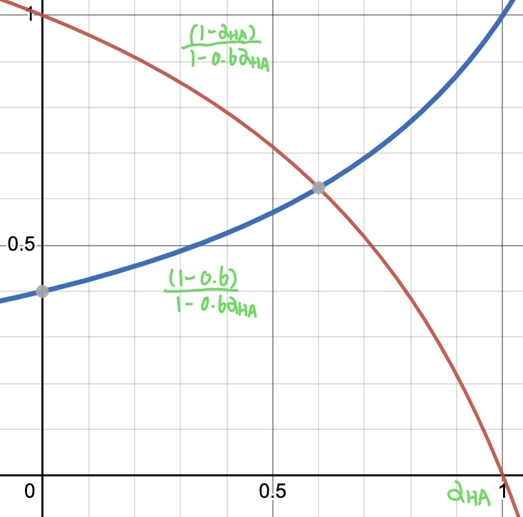图示

**Figure 3 Figure 4**

**However, what is more interesting is if we assume that both AI and humans have a greater influence on each other, namely, ${ α}_{AH}> \frac{K_{A}}{K_{H}}, { α}_{HA}> \frac{K_{H}}{K_{A}}$. We assume this time ${ α}_{AH}$ = 1.6, then after we plot ( $\frac{1-α_{HA}}{1-1.6α_{HA}}, \frac{1-1.6}{1-1.6α_{HA}})$ in Figure 2, with the increase of AI’s influence on humans, especially when AI’s influence on humans is greater than the impact of humans on AI, the original unstable equilibrium approaches the H-axis of figure 2 as $\frac{1-1.6}{1-1.6α_{HA}}$ is moving toward 0, but it does not overlap with the stable equilibrium on the original boundary. In this case, humans may even become the winners of this competition of jobs.**

***Example of Limited Jobs Competition Model***

In this model, we are going to assume that idle AI gets jobs faster than humans, then $β_{2}> β_{1}.$ For example, we set $β_{2}$ =0.8 and $β_{1}$ =0.5. According to the previous analysis, we know **M = $e^{\frac{β_{2}}{β_{1}}}$ $\frac{1}{β_{2}}=6.1913$**  is an essential value of M, so we will pay attention to the cases where M is greater than and less than 6. 1913.

We first let M equal 10, and then equation (25) becomes

$I= e^{\frac{0.8}{0.5}}e^{U}- 0.8*10$**,**

shown as the blue line in the figure 5.

图表

Figure 5

At this time, we can see that this line intersects with U-axis with a positive U value. In this case, idle AI no longer exists while there are still human beings, so AI wins the competition in the case of M=10.

We now let M equal 3, and we have

$I= e^{\frac{0.8}{0.5}}e^{U}- 0.8*3$**.**

It is shown as the green line in the figure 5. Similarly, in the case of M = 3, the unemployed humans will disappear, but there will still be idle AI.

The red line in the figure 5 is the zero point of M for reference. Nevertheless, this can also be regarded as a symbiotic line between AI and humans. Then when M= 6. 1913, humans and AI share all jobs equally, and neither humans nor AI will be unemployed.

**Conclusion**

My models attempt to predict the future competition between humans and AI in jobs from the impact of AI on humans and from the two aspects of AI and humans competing for a limited number of jobs. The first model uses the change of $α_{HA}$**to reflect the bifurcation of each equilibrium point. The result implies that AI's impact on humans will become increasingly considerable. The original symbiotic relationship between humans and AI may eventually become AI that replaces humans when the mutual influence between humans and AI is small initially. This result is consistent with some studies, from which automation will lead to 15% unemployment in 2023, and it will continue to climb to 30% (Manyika & Sneader, 2018). However, this model also tells us that AI will not necessarily replace humans if the mutual influence between humans and AI is significant initially.**

**One limitation of the analysis is that I regard the influence coefficient of AI on humans as an independent variable in the stability analysis to keep it simple. The model will be more accurate if "t" can be introduced in the original differential system. Another more realistic way is instead of plotting a 2-dimensional graph, we can plot a 3-dimensional bifurcation diagram with two independent variables ${ α}_{AH}$**  **and ${ α}_{HA}.$**

In the second model, we mainly predict that after many years, the unemployed, either human or AI, can be eliminated when they jointly compete for a limited number of jobs. The results tell us that the winner of future competitions depends entirely on $e^{\frac{β_{2}}{β_{1}}}$ $\frac{1}{β_{2}}.$ Compared with the first model, this model shows a greater possibility that humans will defeat AI. However, to keep the model simple, I ignore that there fired humans and AI. So if we consider these elements, the model can be more realistic.

**Acknowledgment**

Words cannot express my gratitude to my professor for his invaluable patience and help. I could not have undertaken this paper without my professor, who generously provided knowledge and expertise.

References

Acemoglu, D., & Robinson, J. A. (2012). *Why nations fail: The origins of power, prosperity, and poverty*. Crown Publishers. New York.

Aljanabi, M., Ghazi, M., Ali, A. H., Abed, S. A., & ChatGpt, (2023, January 18). ChatGpt: Open Possibilities. *Iraqi Journal For Computer Science and Mathematics*, 4(1), 62-64. https://journal.esj.edu.iq/index.php/IJCM/article/view/539

Bruun, E. & Duka, A. (2018, November). Artificial Intelligence, Jobs and the Future of Work: Racing with the Machines. *Basic Income Studies*, 13(2), 1-15. https://www-degruyter-com.offcampus.lib.washington.edu/document/doi/10.1515/bis-2018-0018/html#APA

Castelvecchi, D. (2022). *Are ChatGPT and AlphaCode going to replace programmers?* Nature. https://www-nature-com.offcampus.lib.washington.edu/articles/d41586-022-04383-z

Frey, C. B., & Osbourne, M. A. (2017, January). The future of employment: How susceptible are jobs to computerisation? *Technological Forecasting and Social Change*, 114(1), 254-280. https://www-sciencedirect-com.offcampus.lib.washington.edu/science/article/abs/pii/S0040162516302244?via%3Dihub

Klyushin, D., & Tymoshenko, A. (2021). Optimization of Drip Irrigation Systems Using Artificial Intelligence Methods for Sustainable Agriculture and Environment. In *Artificial Intelligence for Sustainable Development: Theory, Practice and Future Applications* (pp. 3-17)*.* Springer, Cham. Switzerlan.

The Lancet Digital Health. (2023, February 6). Chatgpt: Friend or foe? *The Lancet. Digital Health*., 5(3), 1. https://www.thelancet.com/journals/landig/article/PIIS2589-7500(23)00023-7/fulltext

Mantoux, P. (2015). *The Industrial Revolution in the eighteenth century: An outline of the beginnings of the modern factory system in England* (T. S. Ashton, Ed. M. Vernon, Trans.)*.* Routledge. London. (Original work published 1928)

Manyika, J., & Sneader, K. (2018, June 1). *AI, Automation, and the future of work: Ten things to solve for.* McKinsey & Company. https://www.mckinsey.com/featured-insights/future-of-work/ai-automation-and-the-future-of-work-ten-things-to-solve-for

Patel, S. B., & Lam, K. (2023, February 6). Chatgpt: The future of discharge summaries? *The Lancet Digital Health*, 5(3), 1-2. https://www.thelancet.com/journals/landig/article/PIIS2589-7500(23)00021-3/fulltext

Wakefield, J. (2016, May 25). *Foxconn replaces '60,000 factory workers with robots'*. BBC News. https://www.bbc.com/news/technology-36376966